|  |
| --- |
| A.E. MOVIE dATABASE  RAD Development |
| **The Imposters**  130 Murdoch Dr  Murdoch WA, 6150  Phone 1800 001 001  Email imposters@amongus.wa.au |



Table of Contents

# github snapshot

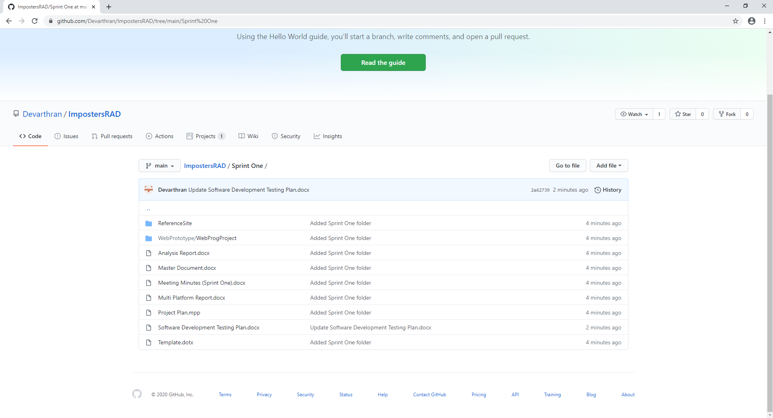

# Project Management Plan

